***Assignment-1***

***(Python lab)***

**1)Write a program that asks the user for a weight in kilograms and converts it to pounds. There are 2.2 pounds in a kilogram?**

1. ***Algorithm:***
2. ***Take a variable p***
3. ***Divided that p with 2.205 Assign that k***

***program:***

**p=float(input("enter pounds="))**

**k=p/2.205**

**print(p,"pounds in kilograms =",k,"kg's")**

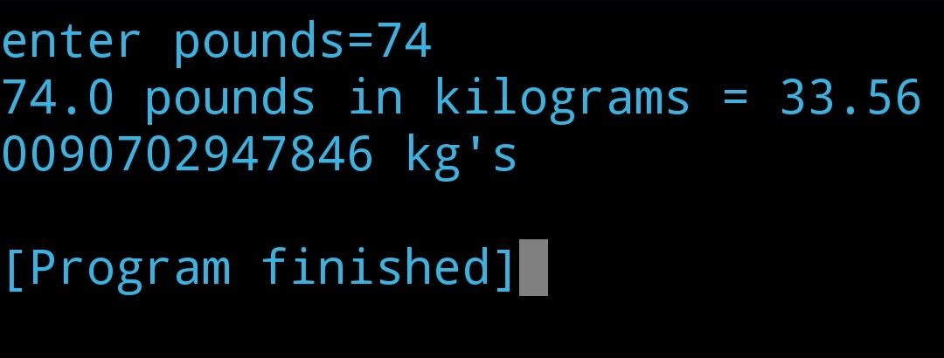***Output:***

***2)* Write a program that asks the user to enter three numbers (use three separate input statements). Create variables called total and average that hold the sum and average of the three numbers and print out the values of total and average.**

**A) *Algorithm:***

1. ***First of all take 3 variables***
2. ***Do the sum of those three variables***
3. ***Now divided sum With three***

***program:***

**a=float(input("enter 1st number="))**

**b=float(input("enter 2nd number="))**

**c=float(input("enter 3rd number="))**

**d=a+b+c**

**e=d/3**

**print("total sum of 3 numbers=",d)**

**print("average of 3 numbers=",e)**

***Output:***

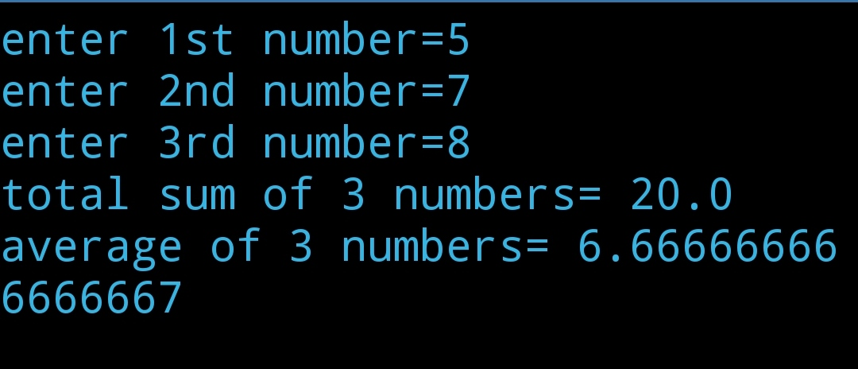

**3) Write a program that uses a for loop to print the numbers 8, 11, 14, 17, 20, . . . , 83, 86, 89.**

**A) Algorithm:**

1. **Use range function , with difference 3 up to 91**

***program:***

**for z in range(8, 91,3):**

**print(z,end=",")**

***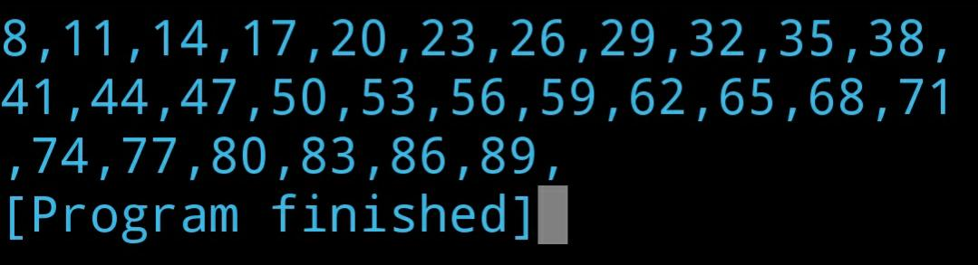* *Output:***

***4) Write a program that asks the user for their name and how many times to print it. The program should print out the user’s name the specified number of times.***

***A) Algorithm:***

***1) use range function to print the name for user choice of times***

***program:***

**n=input("enter your name=")**

**t=int(input("how many times do you want to print your time="))**

**for z in range(0, t):**

**print(n)**

***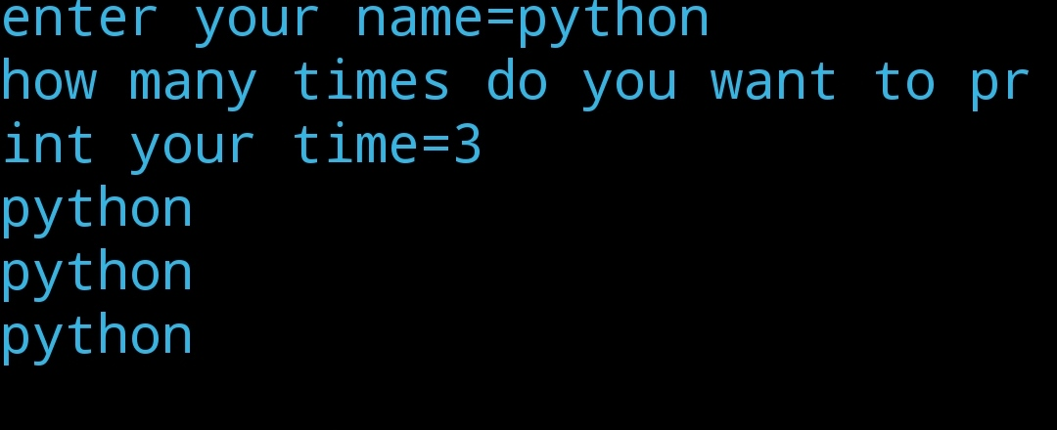* *Output:***

***5) Use a for loop to print a triangle like the one below. Allow the user to specify how high the triangle should be***

***\****

***\*\****

***\*\*\****

***\*\*\*\****

1. ***Algorithm:***
   1. ***Take for loop to print rows***
   2. ***Take another for loop to print columns***
   3. ***Take the range as user wish for rows***
   4. ***Range for column is range of rows +1***

***Program:***

***n=int(input ("enter no of rows="))***

***for a in range(n):***

***for s in range(a+1):***

***print("*",end=" ")***

***print("\n")***

***Output:***

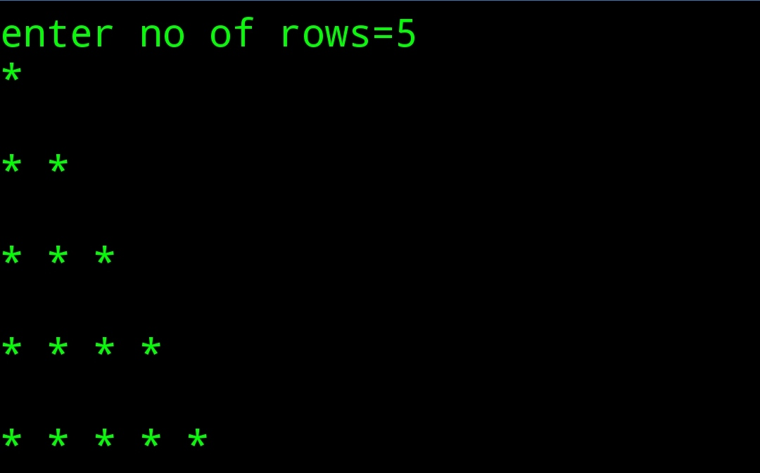

***6) Generate a random number between 1 and 10. Ask the user to guess the number and print a message based on whether they get it right or not.***

***A) Algorithm:***

***1) 1st import randint from random***

***2) selecte a number between 1 and 10***

***3) print the randint number and try to guess it***

***program:***

**from random import randint**

**print("choose number between 1 to 10")**

**c=int(input("selecte a number"))**

**a=randint(1, 10)**

**if c==a:**

**print("your assumption is correct")**

**else:**

**print("your assumption is not correct")**

***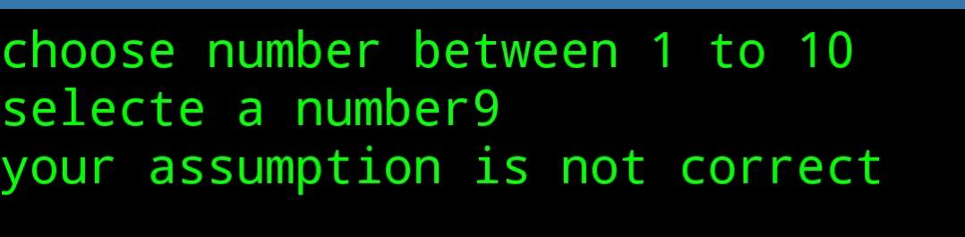* *Output:***

***7) Write a program that asks the user for two numbers and prints Close if the numbers are within .001 of each other and Not close otherwise ?***

***A) program:***

**a=float(input("enter 1st value="))**

**b=float(input("enter 2nd value="))**

**c=a-b**

**if ( round(c, 3)==0.001) or( round(c, 3)==-0.001) :**

**print(c)**

**print(round(0.000999, 3))**

**print(a,"and",b,"are closed")**

**else:**

**print(c)**

**print(a,"and",b,"are not closed")**

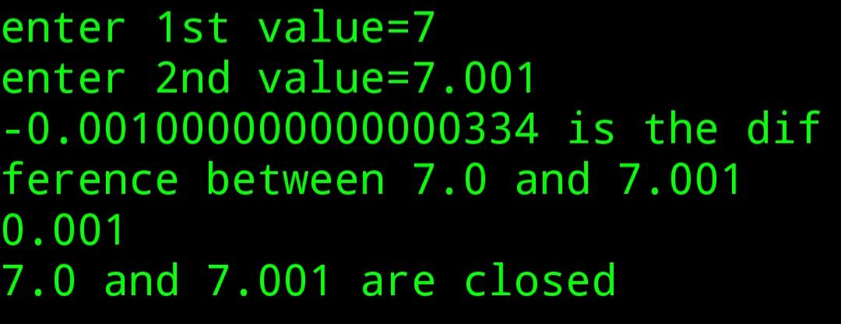***Output:***

***8)*** ***Write a program that asks the user to enter a word and prints out whether that word contains any vowels.?***

***A) program:***

***c=str(input("enter word :"))***

***r=len(c)***

***count=0***

***for i in range(r-1):***

***if (c[i] =='a') or (c[i] =='e') or (c[i] =='i') or (c[i]=='o') or (c[i] =='u') or (c[i] =='A') or (c[i] =='E') or (c[i] =='I') or (c[i] =='O') or (c[i] =='U') :***

***print(" vowel =",c[i])***

***i=i+1***

***count=count+1***

***else:***

***print("",end="")***

***print("there are",count,"vowles in the word",c)***

***print("there are no more vowels in",c,"to print")***

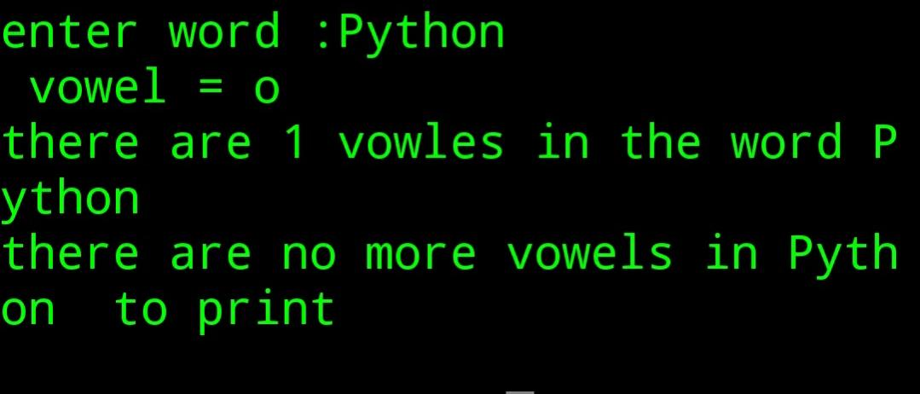***Output:***

***9)*** ***Write a program that asks the user to enter two strings of the same length. The***

***program should then check to see if the strings are of the same length. If they are not,***

***the program should print an appropriate message and exit. If they are of the same***

***length, the program should alternate the characters of the two strings. For example, if***

***the user enters abcde and ABCDE the program should print out AaBbCcDdEe.***

1. ***Program:***

***d=str(input("\tword 1 :"))***

***c=str(input("\tword 2 :"))***

***e=len(d)***

***f=len(c)***

***for i in range(f):***

***if e==f:***

***print(d[i]+c[i],end="")***

***i=i+1***

***else:***

***print("lengths not equal")***

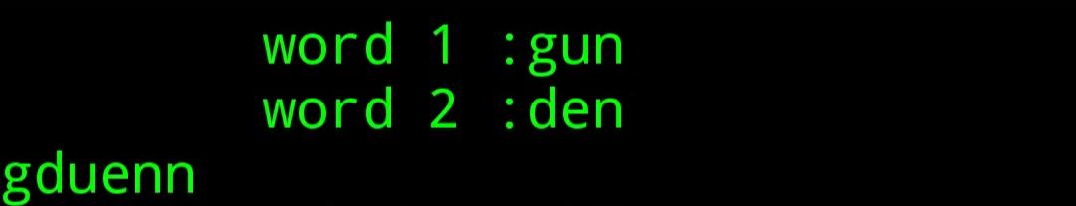***Output:***

***10) Write a program that asks the user for a large integer and inserts commas into it***

***according to the standard American convention for commas in large numbers. For***

***instance, if the user enters 1000000, the output should be 1,000,000.***

1. ***program:***

***n=float(input("Enter a number:"))***

***print("according to the standard American convention the number is {:,}".format(n))***

***Output:***

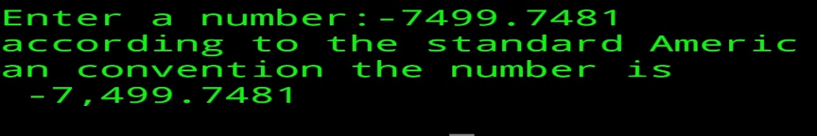

***11) In algebraic expressions, the symbol for multiplication is often left out, as in 3x+4y or 3(x+5). Computers prefer those expressions to include the multiplication symbol, like3*x+4*y or 3*(x+5). Write a program that asks the user for an algebraic expression and then inserts multiplication symbols where appropriate.?***

***Program:***

***12) Write a program that generates a list of 20 random numbers between 1 and 100.***

***(a) Print the list.***

***(b) Print the average of the elements in the list.***

***(c) Print the largest and smallest values in the list.***

***(d) Print the second largest and second smallest entries in the list***

***(e) Print how many even numbers are in the list.***

***A) program:***

***from random import randint***

***sum=0***

***count=0***

***li=[]***

***for i in range(20):***

***li.append(randint(0, 100))***

***print( "list of 20 random numbers",li)***

***li.sort()***

***print(" sorted list is=",li)***

***for i in range(20):***

***sum=sum+li[i]***

***d=li[0]***

***f=li[19]***

***j=li[1]***

***k=li[18]***

***n=li[i]%2***

***if n==0:***

***count=count+1***

***print(count, "even")***

***print(f,"largest number")***

***print(d,"smallest number")***

***print(j,"2nd smallest number")***

***print(k, "2nd largest number")***

***print("sum of numbers of the list is",sum)***

***m=sum/20***

***print("average of 20 random numbers=",m)***

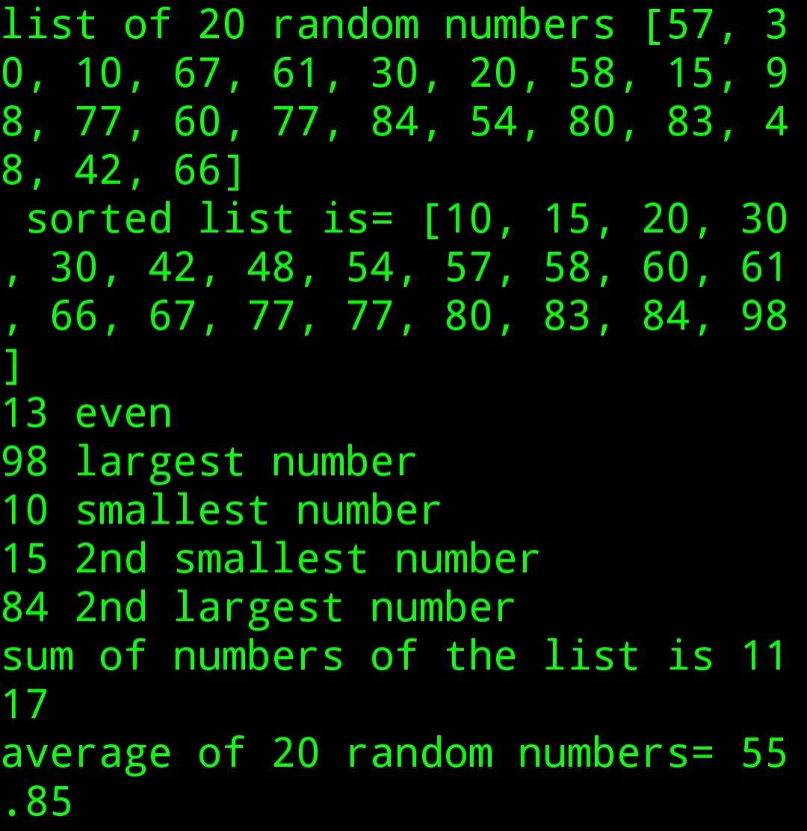***Output:***

***13) Write a program that asks the user for an integer and creates a list that consists of the factors of that integer.?***

***A) program:***

***a=int(input ("enter a :"))***

***n=1***

***li=[]***

***for x in range (a):***

***if a%n==0:***

***li.append(n)***

***n=n+1***

***else:***

***n=n+1***

***print("",end="")***

***print("factors of ",a," are",li)***

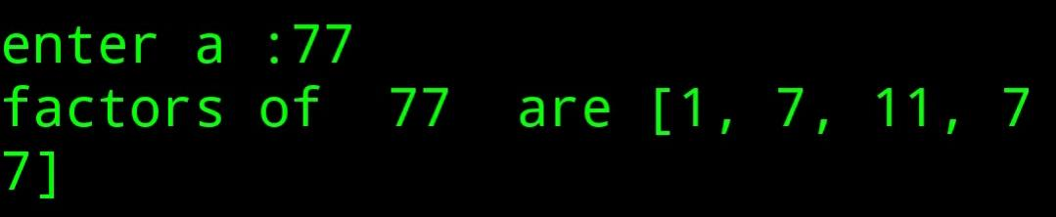***Output:***

***14) Write a program that generates 100 random integers that are either 0 or 1. Then find***

***the longest run of zeros, the largest number of zeros in a row. For instance, the longest***

***run of zeros in [1,0,1,1,0,0,0,0,1,0,0] is 4.***

***A) program:***

***from random import randint***

***li=[]***

***count=0***

***for k in range(100):***

***li.append(randint(0, 1))***

***for h in range(100):***

***if li[h]==0:***

***count=count+1***

***print (li)***

***print(count,"zero's are there in the above list")***

***Output:***

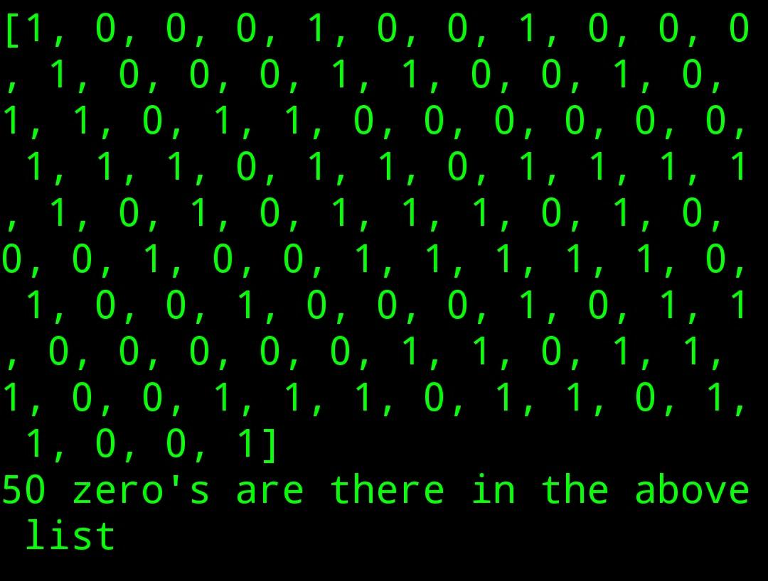

***15) Write a program that removes any repeated items from a list so that each item appears at most once. For instance, the list [1,1,2,3,4,3,0,0] would become [1,2,3,4,0].***

***A) program:***

***a=list(input ("enter a list="))***

***s=list(dict.fromkeys(a))***

***print(s)***

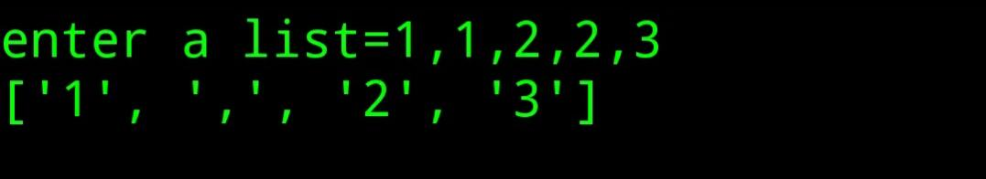***Output:***

***16) Write a program that asks the user to enter a length in feet. The program should then give the user the option to convert from feet into inches, yards, miles, millimeters,centimeters, meters, or kilometers. Say if the user enters a 1, then the program converts to inches, if they enter a 2, then the program converts to yards, etc. While this can be done with if statements,it is much shorter with lists and it is also easier to add new conversions if you use lists.?***

***A) program:***

***c=float(input("enter length in feet ="))***

***print("********************************")***

***print ("to convert length in feet into inches enter 1")***

***print ("to convert length in feet into yards enter 2")***

***print ("to convert length in feet into Milies enter 3")***

***print ("to convert length in feet into millimetres enter 4")***

***print ("to convert length in feet into centimetres enter 5")***

***print ("to convert length in feet into kilometers enter 6")***

***print ("to convert length in feet into metres enter 7")***

***print("********************************")***

***a=int(input ("chose your option ="))***

***if a==1:***

***s=12*c***

***print(s,"inches")***

***elif a==2:***

***y=c/3***

***print(y,"yard")***

***elif a==3:***

***m=c/5280***

***print(m,"miles")***

***elif a==4:***

***n=c*304.8***

***print(n,"millimeters")***

***elif a==5:***

***u=c*30.48***

***print(u,"centimeters")***

***elif a==6:***

***v=c*0.000305***

***print(v,"kilometer")***

***elif a==7:***

***p=c*0.305***

***print(p, "meter")***

***else:***

***print("chose correct opoption")***

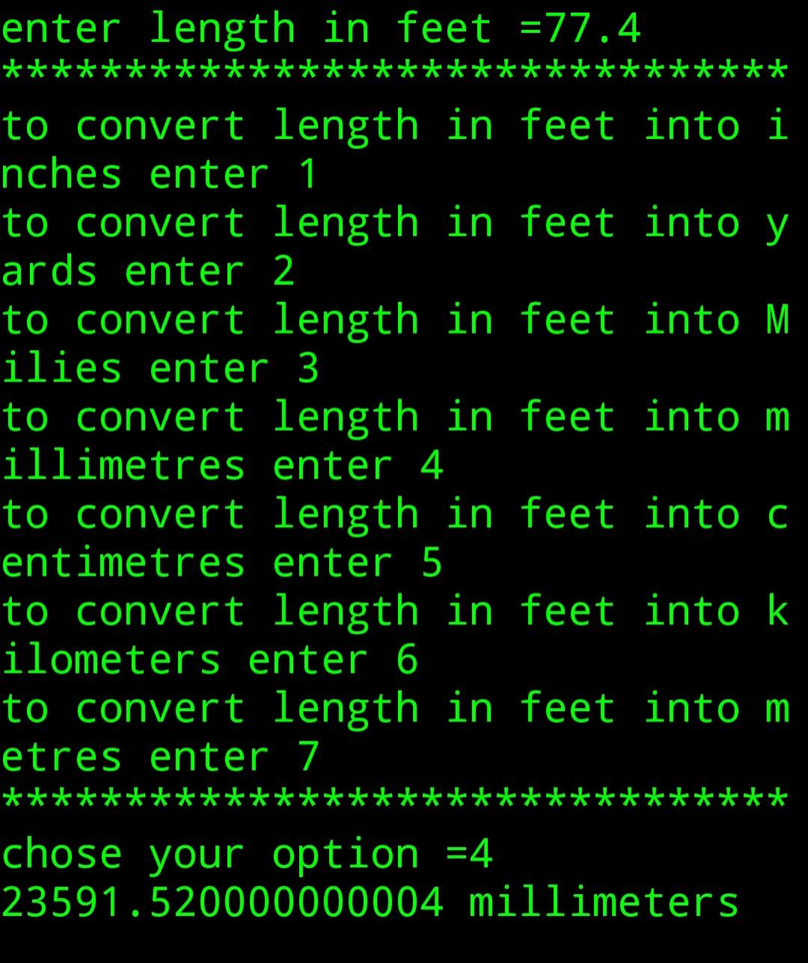***Output:***

***17) Write a function called sum_digits that is given an integer num and returns the sum of the digits of num.?***

***A) program:***

***18) Write a function called first_diff that is given two strings and returns the first location in which the strings differ. If the strings are identical, it should return -1.***

***A) program:***

***def frist_diff():***

***a=str(input ("enter word :"))***

***b=str(input ("enter another word :"))***

***f=len(a)***

***h=len(b)***

***if f>h or f>=h or f==h:***

***r=len(a)***

***p=(r+1)***

***else :***

***r=len(b)***

***p=(r-1)***

***if a==b:***

***print("-1")***

***else:***

***for v in range (r):***

***if a[v]==b[v]:***

***print(v, "location")***

***v=v+1***

***break***

***else:***

***print(end="")***

***frist_diff()***

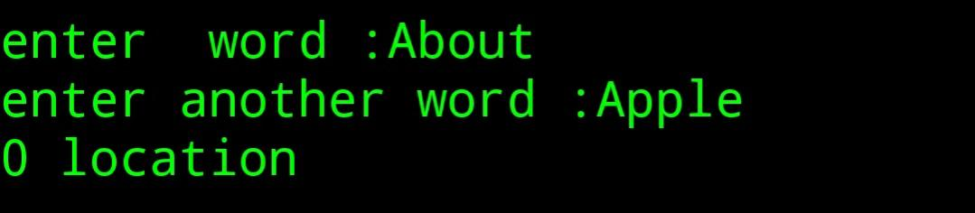***Output:***

***19) Write a function called number_of_factors that takes an integer and returns how many factors the number has.?***

***A) program:***

***a=int(input ("enter number :"))***

***def number_of_factors():***

***n=1***

***li=[]***

***for x in range (a):***

***if a%n==0:***

***li.append(n)***

***n=n+1***

***else:***

***n=n+1***

***print("",end="")***

***print("factors of",a ,"are",li)***

***r=len(li)***

***print("total number of factors of",a,"are",r)***

***number_of_factors()***

***output:***

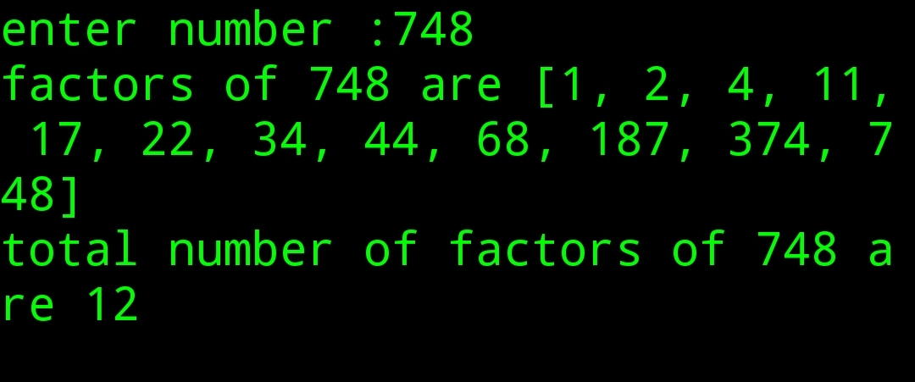

***20) Write a function called is_sorted that is given a list and returns True if the list is sorted and False otherwise.?***

***A) program :***

***li=[]***

***k=int(input ("enter range of the list :"))***

***for v in range(k):***

***a=int(input("num of the list :"))***

***li.append(a)***

***n=li***

***e=sorted(n)***

***o=sorted (n, reverse=True)***

***if (n==e) or (n==o):***

***print("you entered correct oder")***

***else:***

***print("you didn't entered correct oder")***

***print(e,"or",o,"these is the correct order"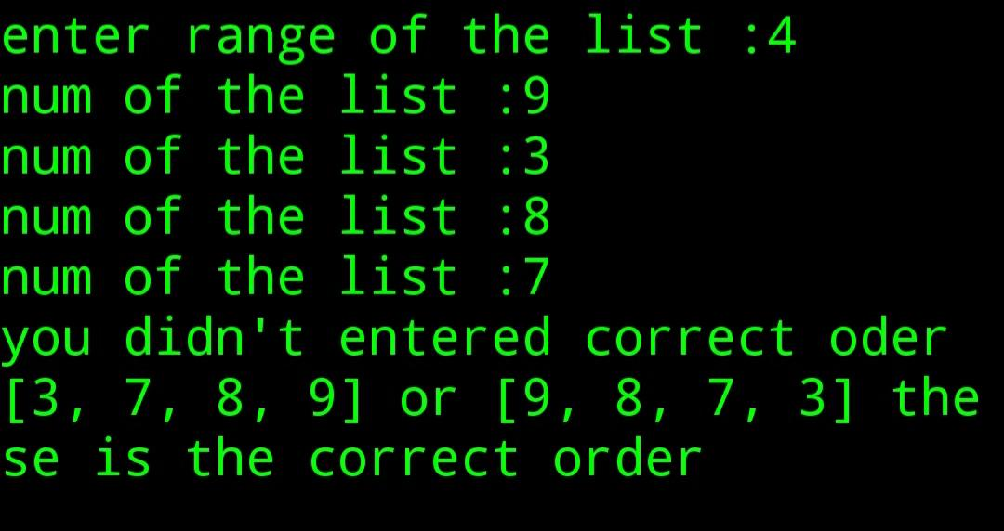)***

***21) Write a function called root that is given a number x and an integer n and returns x1/n In the function definition, set the default value of n to 2.***

***A) program:***

***def root():***

***c=float(input("enter number="))***

***print("nth root i.e, in the form\n 1/nth root")***

***p=float(input("enter nth root to find="))***

***v=1/p***

***a=pow(c, v)***

***y=round(a,1)***

***print(p,"th root of",c,"is",a,"\n","i.e, is",y)***

***root()***

***output:***

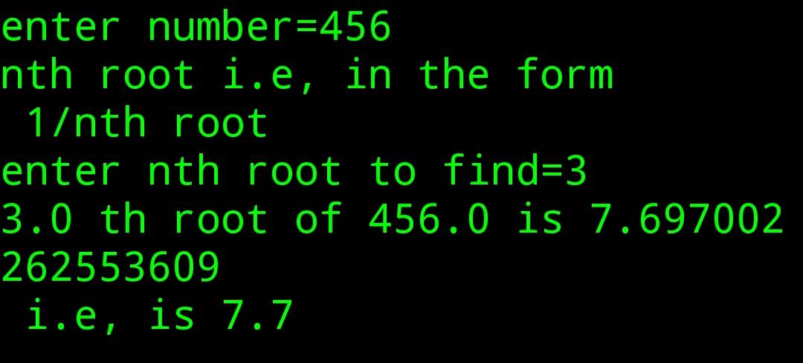

***22) Write a function called primes that is given a number n and returns a list of the first n primes. Let the default value of n be 100.***

***A) program:***

***print ("2 and 3 are primes")***

***def primes():***

***li=[]***

***l=[]***

***print("enter range")***

***a=int(input("enter left closing value"))***

***b=int(input("enter right closing value"))***

***for n in range(a, b):***

***if n%2 !=0 and n%3 !=0 :***

***li.append(n)***

***else:***

***l.append(n)***

***if a<10 and b<=4:***

***if b!=3:***

***l.remove(2)***

***l.remove(3)***

***li.append(2)***

***li.append(3)***

***else:***

***l.remove(2)***

***li.append(2)***

***elif a<10 :***

***l.remove(3)***

***l.remove(2)***

***li.append(2)***

***li. append(3)***

***elif a<10 and b>1 :***

***l.remove(3)***

***l.remove(2)***

***li.append(2)***

***li. append(3)***

***li.sort()***

***print(li,"=primes in range",a, "to",b,"\n")***

***l.sort()***

***print(l,"=not primes in range",a,"to",b)***

***primes()***

***Output:***

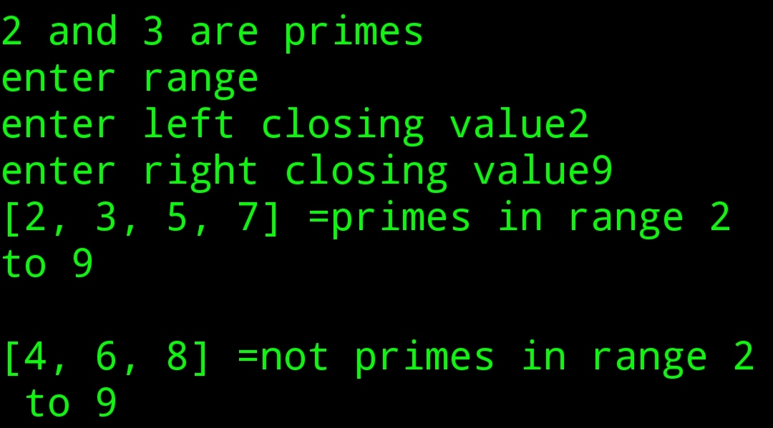

***23) Write a function called merge that takes two already sorted lists of possibly different lengths, and merges them into a single sorted list.***

***(a) Do this using the sort method. (b) Do this without using the sort method.***

***A) program:***

***24) Write a program that asks the user for a word and finds all the smaller words that can be made from the letters of that word. The number of occurrences of a letter in a smaller word can’t exceed the number of occurrences of the letter in the user’s word.***

***A) program:***